Network Lag

🕓 What Is Network Lag?
# Source: AI Source: Provided by: [Data Path: Persons Table -> ID Column: 1, Name_En Column: Motasem Essam] -> From: [ChatGPT] on [12/15/2025]
Network lag refers to the delay (latency) between when data is sent over a network and when it’s received at the destination.
It’s what causes things like slow-loading websites, delayed gaming actions, or buffering videos.

✅ Simple Definition:
# Source: AI Source: Provided by: [Data Path: Persons Table -> ID Column: 1, Name_En Column: Motasem Essam] -> From: [ChatGPT] on [12/15/2025]
Lag is the time delay in a network — the longer it takes for data to travel, the more lag you experience.

🧠 Real-Life Analogy:
# Source: AI Source: Provided by: [Data Path: Persons Table -> ID Column: 1, Name_En Column: Motasem Essam] -> From: [ChatGPT] on [12/15/2025]
Imagine shouting across a canyon:
- You shout: “Hello!”
- It takes a few seconds before you hear the echo back
That delay is similar to network lag — especially in real-time communication like gaming or video calls.

📏 Measured in: Milliseconds (ms)
# Source: AI Source: Provided by: [Data Path: Persons Table -> ID Column: 1, Name_En Column: Motasem Essam] -> From: [ChatGPT] on [12/15/2025]
- ✅ 0–50 ms: Very fast (real-time apps, gaming)
- ⚠️ 50–150 ms: Acceptable for most apps
- ❌ 150+ ms: Noticeable delay, frustrating for users

🔍 Causes of Network Lag
# Source: AI Source: Provided by: [Data Path: Persons Table -> ID Column: 1, Name_En Column: Motasem Essam] -> From: [ChatGPT] on [12/15/2025]
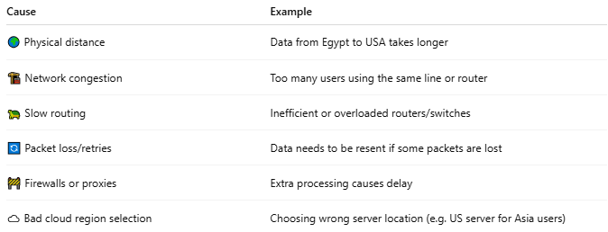

Cause | Example
🌍 Physical distance | Data from Egypt to USA takes longer
🏗 Network congestion | Too many users using the same line or router
🐢 Slow routing | Inefficient or overloaded routers/switches
🔄 Packet loss/retries | Data needs to be resent if some packets are lost
🚧 Firewalls or proxies | Extra processing causes delay
☁️ Bad cloud region selection | Choosing wrong server location (e.g. US server for Asia users)

🎮 Example in Gaming:
# Source: AI Source: Provided by: [Data Path: Persons Table -> ID Column: 1, Name_En Column: Motasem Essam] -> From: [ChatGPT] on [12/15/2025]
- You shoot, but the enemy dies a second later.
- You press a key, and the response feels delayed.
That's network lag — and it kills real-time experience.

🖥️ Example in Web or API:
# Source: AI Source: Provided by: [Data Path: Persons Table -> ID Column: 1, Name_En Column: Motasem Essam] -> From: [ChatGPT] on [12/15/2025]
- A user clicks “Submit” → The page freezes for 2 seconds before responding.
- High latency in an API → Slower frontend or app performance.

📈 How to Reduce Network Lag
# Source: AI Source: Provided by: [Data Path: Persons Table -> ID Column: 1, Name_En Column: Motasem Essam] -> From: [ChatGPT] on [12/15/2025]
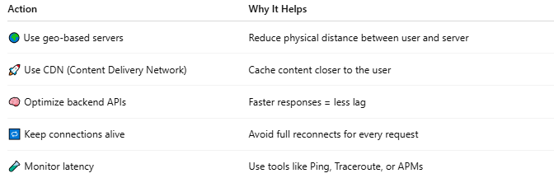

Action | Why It Helps
🌍 Use geo-based servers | Reduce physical distance between user and server
🚀 Use CDN (Content Delivery Network) | Cache content closer to the user
🧠 Optimize backend APIs | Faster responses = less lag
🔁 Keep connections alive | Avoid full reconnects for every request
🧪 Monitor latency | Use tools like Ping, Traceroute, or APMs

🧪 How to Test Network Lag
# Source: AI Source: Provided by: [Data Path: Persons Table -> ID Column: 1, Name_En Column: Motasem Essam] -> From: [ChatGPT] on [12/15/2025]
Great! Here's how you can test your network lag and use tools to monitor and improve it:

1. Ping (Built-in Command)
# Source: AI Source: Provided by: [Data Path: Persons Table -> ID Column: 1, Name_En Column: Motasem Essam] -> From: [ChatGPT] on [12/15/2025]
Measures the round-trip time for a packet between your computer and a server.
📌 How to use:
- On Windows: Open Command Prompt
- On macOS/Linux: Open Terminal
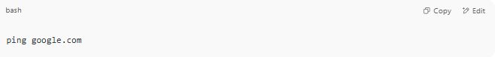
ping google.com

🧾 Example result:
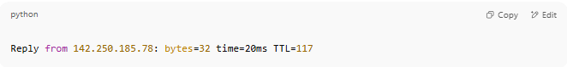
Reply from 142.250.185.78: bytes=32 time=20ms TTL=117

🟢 time=20ms → This is the latency (low = good)

2. Traceroute
# Source: AI Source: Provided by: [Data Path: Persons Table -> ID Column: 1, Name_En Column: Motasem Essam] -> From: [ChatGPT] on [12/15/2025]
Shows the path your request takes through the network — helps identify slow points (hops).
- On Windows:
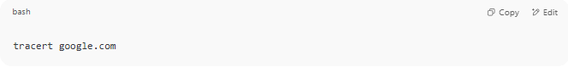
tracert google.com

- On macOS/Linux:
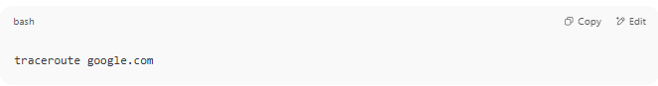
traceroute google.com

3. Online Tools
# Source: AI Source: Provided by: [Data Path: Persons Table -> ID Column: 1, Name_En Column: Motasem Essam] -> From: [ChatGPT] on [12/15/2025]

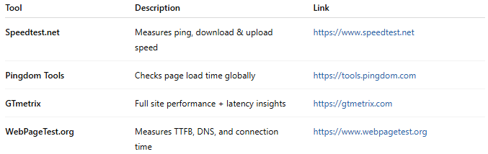
Tool | Description | Link
Speedtest.net | Measures ping, download & upload speed | https://www.speedtest.net
Pingdom Tools | Checks page load time globally | https://tools.pingdom.com
GTmetrix | Full site performance + latency insights | https://gtmetrix.com
WebPageTest.org | Measures TTFB, DNS, and connection time | https://www.webpagetest.org

⚙️ Developer Tools for Ongoing Monitoring
# Source: AI Source: Provided by: [Data Path: Persons Table -> ID Column: 1, Name_En Column: Motasem Essam] -> From: [ChatGPT] on [12/15/2025]
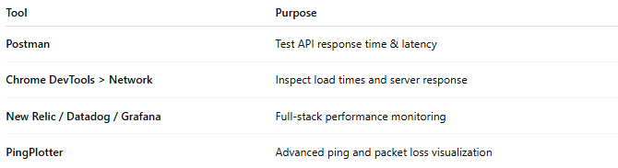

Tool | Purpose
Postman | Test API response time & latency
Chrome DevTools > Network | Inspect load times and server response
New Relic / Datadog / Grafana | Full-stack performance monitoring
PingPlotter | Advanced ping and packet loss visualization

📉 If Lag Is High — Here's How to Reduce It:
# Source: AI Source: Provided by: [Data Path: Persons Table -> ID Column: 1, Name_En Column: Motasem Essam] -> From: [ChatGPT] on [12/15/2025]
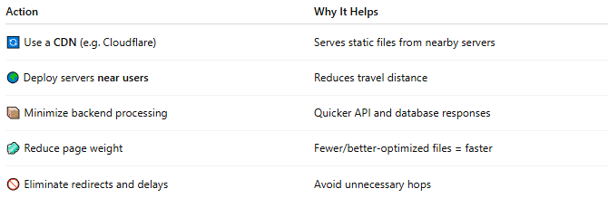

Action | Why It Helps
🔄 Use a CDN (e.g. Cloudflare) | Serves static files from nearby servers
🌍 Deploy servers near users | Reduces travel distance
📦 Minimize backend processing | Quicker API and database responses
🧼 Reduce page weight | Fewer/better-optimized files = faster
🚫 Eliminate redirects and delays | Avoid unnecessary hops

✅ Quick Tip:
# Source: AI Source: Provided by: [Data Path: Persons Table -> ID Column: 1, Name_En Column: Motasem Essam] -> From: [ChatGPT] on [12/15/2025]
To test API or website latency in Postman, just look at the response time after sending a request. You can also:
- Use console.log(Date.now()) to time frontend delays
- Monitor TTFB (Time To First Byte) for slow responses

Network Lag vs Network Latency

1. Network Latency
# Source: AI Source: Provided by: [Data Path: Persons Table -> ID Column: 1, Name_En Column: Motasem Essam] -> From: [ChatGPT] on [12/15/2025]
Definition:
Network latency is the time it takes for a packet of data to travel from the sender to the receiver (or back, if measured as RTT).
- Measured in milliseconds (ms)
- Represents the delay inherent in the network
- Caused by factors like:
  - Physical distance between devices
  - Routing and switching delays
  - Queuing at network devices
  - Propagation and transmission delay
Example:
If a ping to a server shows 50 ms, the network latency is 50 ms.

2. Network Lag
# Source: AI Source: Provided by: [Data Path: Persons Table -> ID Column: 1, Name_En Column: Motasem Essam] -> From: [ChatGPT] on [12/15/2025]
Definition:
Network lag is the perceived delay experienced by users in applications like online games, video calls, or streaming.
- Often caused by high latency, but can also be due to:
  - Packet loss
  - Jitter (variation in delay)
  - Congestion
  - Server or application processing delays
Example:
- In a game, you press a button, but the action appears 200 ms later.
- That delay is “lag,” which may be caused by high latency, but also by slow server response.

Key Differences
# Source: AI Source: Provided by: [Data Path: Persons Table -> ID Column: 1, Name_En Column: Motasem Essam] -> From: [ChatGPT] on [12/15/2025]
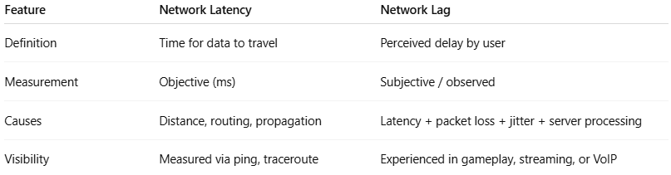
Feature | Network Latency | Network Lag
Definition | Time for data to travel | Perceived delay by user
Measurement | Objective (ms) | Subjective / observed
Causes | Distance, routing, propagation | Latency + packet loss + jitter + server processing
Visibility | Measured via ping, traceroute | Experienced in gameplay, streaming, or VoIP

Analogy
# Source: AI Source: Provided by: [Data Path: Persons Table -> ID Column: 1, Name_En Column: Motasem Essam] -> From: [ChatGPT] on [12/15/2025]
- Latency: How long it takes a letter to reach your friend
- Lag: How long it feels until you get a reply and notice it

✅ Takeaway:
# Source: AI Source: Provided by: [Data Path: Persons Table -> ID Column: 1, Name_En Column: Motasem Essam] -> From: [ChatGPT] on [12/15/2025]
- Latency is a technical measurement of delay.
- Lag is the user’s experience of delay, which may include latency and other factors.

📌 Summary
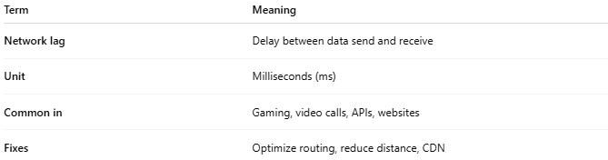

Term | Meaning
Network lag | Delay between data send and receive
Unit | Milliseconds (ms)
Common in | Gaming, video calls, APIs, websites
Fixes | Optimize routing, reduce distance, CDN

